Вкладка 1

Installing PostgreSQL and pgAdmin
In this tutorial we will install and set up Postgres server and pgAdmin for Windows, MacOS and Ubuntu (Linux distro) Operating Systems.

Installing PostgreSQL server

Windows:
1) Go to download page
2) Select latest version for Windows
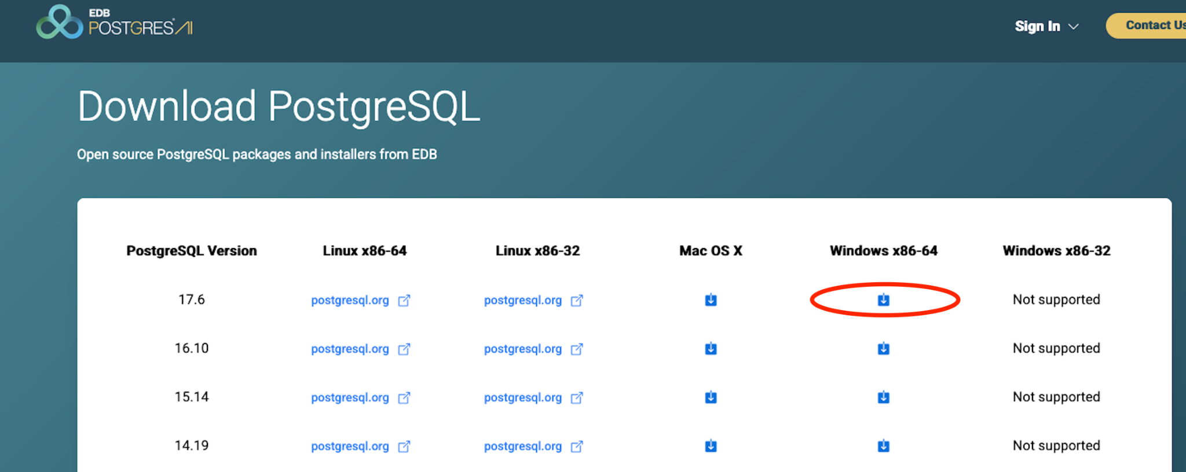
3) Click downloaded installation file
4) Follow the installation process
5) Add postgres to PATH

Ubuntu:
1) Open your terminal and run command bellow:
sudo apt install postgresql postgresql-contrib

2) To verify you installed postgresql run command bellow:
psql --version
# You will see postgres version
psql (PostgreSQL) 17.5 (Ubuntu 17.5-1.pgdg24.04+1)

3) Ensure you start the server:
sudo service postgresql start

Here is how you can manage your postgres server:
# Check server status
sudo service postgresql status
# Start server
sudo service postgresql start
# Restart server
sudo service postgresql restart
# Stop server
sudo service postgresql stop

4) By default, PostgreSQL creates a user named postgres. Access the postgres console:
sudo -u postgres psql

5) Set up password to postgres user:
ALTER USER postgres WITH PASSWORD 'your_password';

6) Excite the server:
\q

Mac:
1) Install postgres using homebrew:
brew install postgresql

2) After the installation, start PostgreSQL server:
brew services start postgresql

3) By default, PostgreSQL creates a user named by your system username:
psql postgres

4) Set up password to postgres user:
ALTER USER your_username WITH PASSWORD 'your_password';

Installing pgAdmin

About:
pgAdmin is the leading free and open-source graphical management and development platform for PostgreSQL databases

Windows:
When installing PostgreSQL on Windows, this program is included in the basic installation package, so no additional installation is required. To launch the program, we can find the pgAdmin icon in the Start menu and run it:
1) When you open it, a window will pop up asking you to enter your password to connect to the server. Just type it in:
2) After successfully logging in, we will see the contents of the server: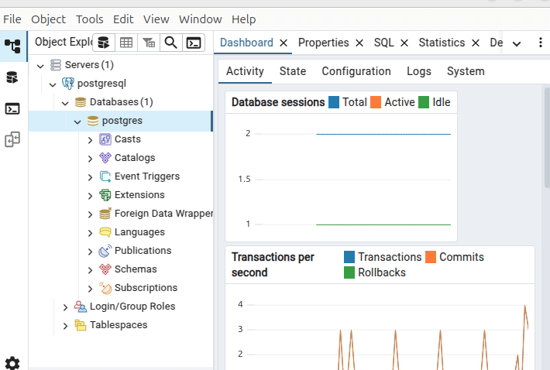

Ubuntu:
1) Run commands bellow:
curl -fsS https://www.pgadmin.org/static/packages_pgadmin_org.pub | sudo gpg --dearmor -o /usr/share/keyrings/packages-pgadmin-org.gpg
sudo sh -c 'echo "deb [signed-by=/usr/share/keyrings/packages-pgadmin-org.gpg] https://ftp.postgresql.org/pub/pgadmin/pgadmin4/apt/$(lsb_release -cs) pgadmin4 main" > /etc/apt/sources.list.d/pgadmin4.list && apt update'
sudo apt install pgadmin4

2) Open pgAdmin and register server:
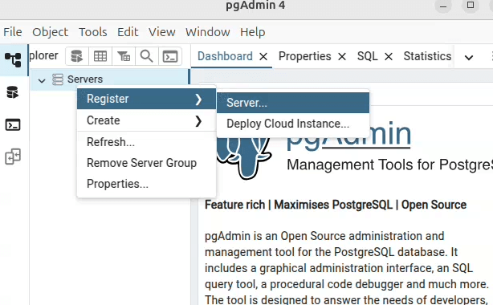

3) Name server:
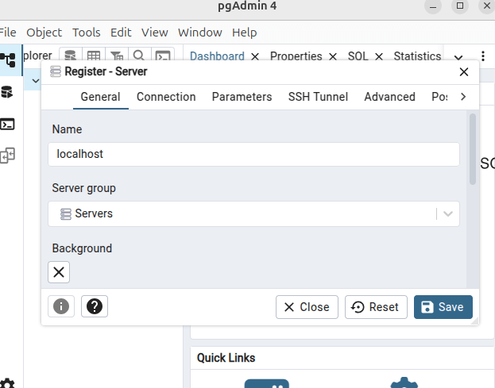
4) Feel connection server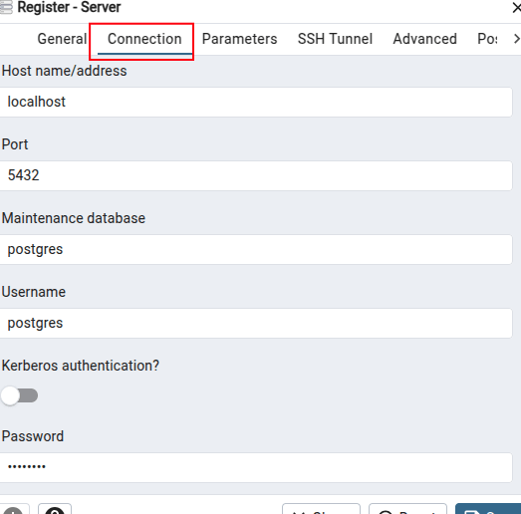

Mac:
1) Run command bellow:
brew install --cask pgadmin4

2) Open pgAdmin and register localhost server
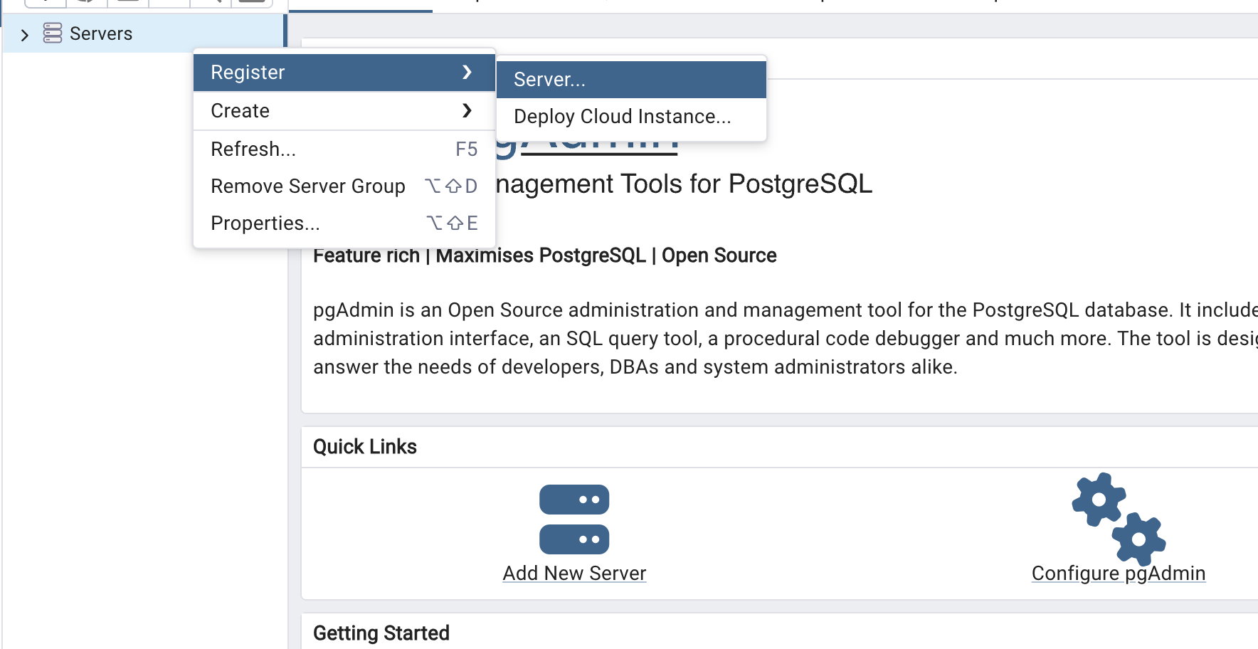
3) Name your server:
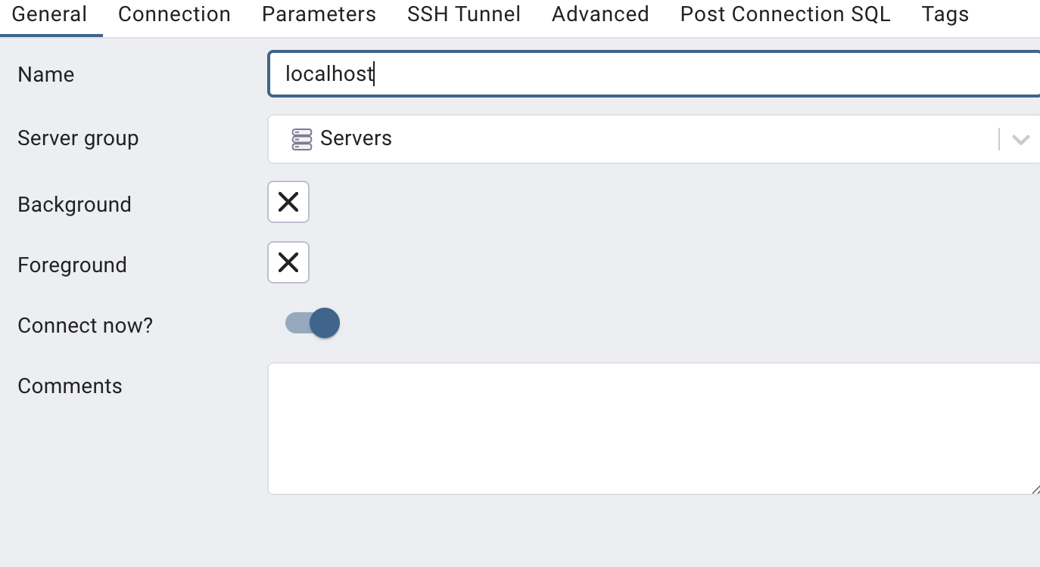

4) Set up Connection section
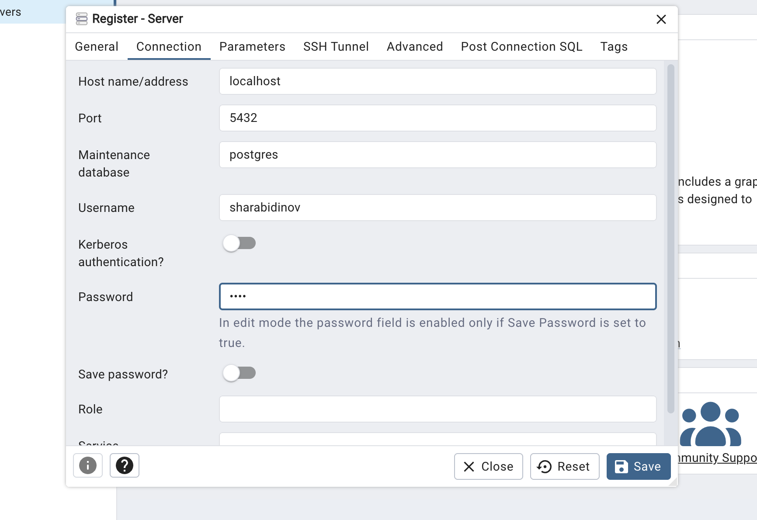5) After we register our server you can see content of our server
